Asimov, Young Star Travelers, Harper & Row1986 Library bound, First Edition, First Print full print line. Very good dust jacket price $12.89 in mylar taped to the book. Near fine hard cover with all 209 pages tightly bound and no marks in text, library stamp on title page and library stickers and marks inside front cover and first page. Cover art Lizzy Rockwell. 8vo, ISBN 0060201797

ID 000348 Price $30 Box 7

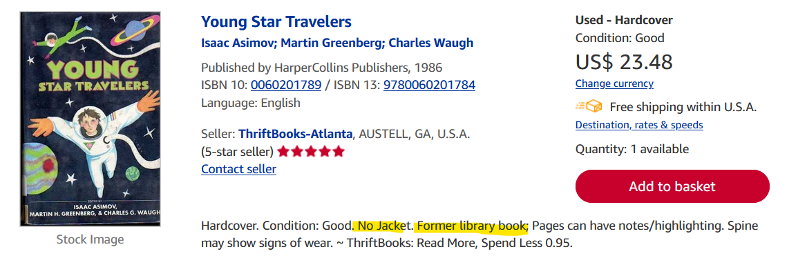
AbeBooks

